## Title:

Rebuttal to Frank et al 2016

## Authors:

NAFC1Montevecchi WA2  
Robert D3  
Davoren GK4  
Rose G5?

## Affiliations:

1. Northwest Atlantic Fisheries Centre, Fisheries and Oceans Canada, St. John's, NL, Canada
2. Cognitive and Behavioural Ecology Programme, Departments of Biology and Psychology, Memorial University of Newfoundland, St. John’s, NL, Canada
3. Institut des sciences de la mer, Université du Québec à Rimouski, Rimouski, QC, Canada
4. Department of Biological Sciences, University of Manitoba, Winnipeg, MB, Canada
5. CFER/ UBC ?

## Abstract

Fish surveys

We briefly describe here the general procedures of the spring and fall capelin acoustic surveys.

Spring and fall acoustics surveys

Spring acoustic surveys have happened in most years since 1980 while fall acoustic surveys were conducted from 1982 through 1993 and have not been undertaken since 1994. The survey design and implementation have changed significantly over time and a more detailed description of the acoustic survey program is provided in Mowbray (2014) . The current design consists of a series of equidistant apart (15 to 30 nautical miles) parallel acoustic survey transect lines with survey effort being partitioned amongst a number of strata that were classed as core (e.g. highest priority) or non-core (e.g. lowest priority). The position of the initial transect line is randomly determined while the positions of subsequent lines are dependent on the position of the initial line. Targeted fishing sets were conducted, as required, to determine the species composition of the acoustic backscatter. Additional fishing sets were conducted periodically to confirm the absence of fish signal with a minimum of one set being conducted every 12 hour period during all surveys. Prior to 1996, a large mid-water trawl (Diamond IX) was used to collect biological samples. Since 1996, both mid-water (IYGPT) and bottom trawls (Campelen 1800) have been used to collect samples. Set duration ranges from 15 to 120 minutes depending on mode of deployment and the intensity of the backscatter to be verified. For each set, the total number and weight of each species caught was recorded. The total length, sex and maturity status were recorded for a maximum of 200 randomly selected capelin from each catch. Additional, detailed sampling was conducted on two capelin of each sex for each 0.5 cm length group. For those capelin, round weight, gonad weight, and stomach fullness were determined, otoliths were removed for aging, and stomach contents were identified to the lowest practical taxonomic status and their lengths were measured. The age composition of the capelin surveyed using acoustics was determined using age-length keys that were derived from the age, length, and sex data of the capelin collected in the biological samples for each Division and year.

Fall multispecies survey

<details needed>

2J3KL using a Campelen 1800 trawl; This survey has been conducted in Div since 1995.

Inshore commercial capelin fishery

In addition to the acoustic and multispecies bottom trawl surveys , the Department of Fisheries and Oceans Canada also surveys the catches from the inshore commercial capelin fishery. Four primary gear types are used in the inshore commercial capelin fishery in Divisions 3K and 3L: a trap fishery, beach seining, purse seining and more recently tuck seines. For each gear type, in each bay, for each week, one sample of 200 fish is collected per 500 tonnes of capelin landed using that gear type. The lengths, sex, and maturity status is determined for all 200 fish collected per sample. For a length stratified subset of the catch, 2 fish of each sex for each 0.5 cm length is further examined in order to determine their ages using otoliths, their whole weights and gonad weights and in more recent years, their stomach fullness is also determined. The age composition of the commercial catch is then determined using age-length keys that are generated on a monthly basis with separate keys being developed for sexes, fishing gear, month, and division.

In the absence of an absolute abundance estimate for the 2J3KL capelin stock, researchers in recent years have utilised an index generated from a spring acoustic survey (see table 1, Frank et al 2016, Mowbray, 2014) (Fig 1). However, this survey has limited spatial coverage. At the time of inception for the NW Atlantic acoustic surveys for capelin, NAFO Divisions 2J3KL were considered to contain two stocks, one in the 2J3K portion and one in the 3L portion (Campbell and Winters, 1973). Acoustic surveys were designed to assess the two “stocks” separately: a spring offshore acoustic survey (SOAS) conducted in May in Division 3L, timed to intercept capelin during spring feeding just prior to their spawning migration and a fall offshore acoustic survey (FOAS) conducted from October through November in Division 2J3K, designed to intercept capelin during the fall feeding period. Later, in light of evidence from meristic and tagging studies (Misra and Carscadden 1984 and Nakashima 1992) stock definitions were amended and 2J3KL has since been considered a single stock unit. More recently a population genetics study using 6 microsatellite markers (Kenchington, Nakashima, Taggart, & Hamilton, 2015), suggested that the stock boundaries may be broader still with no significant differences evident among beach spawners from Divisions 2J3KL , 3Ps and the Scotian Shelf. This evolution in stock definitions has resulted in surveys which do not provide synoptic stock coverage. Capelin catch at age information from the fall multispecies(?) random stratified bottom trawl survey demonstrates one such issue. Given that catchability of pelagic fish in bottom trawls is negatively impacted by fish density, vertical migration and the presence of demersal predators (McQuinn 2009) abundance estimates of pelagic fish from this survey cannot replace an acoustic survey estimate and the data collected serve only as a coarse estimate of even the behavioural characteristics of pelagic fish such as their spatial distribution. However, multiyear trends in the bottom trawl survey index have been shown to trend in the same direction as the trends from the spring acoustic survey (Fig FM2) and catches from bottom trawl surveys are used to describe capelin distribution (Grégoire et al, 2013 ). Age dependent distributions of capelin from the fall multispecies bottom trawl survey indicated a latitudinal cline in age composition with the youngest capelin in the south and the older ages more prevalent in the northern Divisions (2J, 3K). This pattern of age dependent spatial distribution has been consistent between periods of low (2002-2004) and moderate (2013-2015) acoustic survey abundance, although a larger proportion of age 1 fish were present in 3L during the low abundance period (Fig FM3). Unfortunately, prior to 1991, when capelin were most abundant, the fall bottom trawl survey employed an Engels trawl which retained few capelin, meaning a similar analysis could not be conducted for earlier periods. Data on the age distribution of capelin from the fall 2J3K acoustic survey are, however, available for this period. The fall acoustic survey was spatially limited, only being extended to include Division 3L following the collapse in 1991. The data from the fall acoustic survey provides a similar picture of a latitudinal cline in age during both low and high abundance periods.

The age dependent distribution of capelin presents issues for the use of both spring and fall acoustic survey results as abundance indices. During spring acoustic surveys age-1 capelin (hatched the previous summer), have such a weak acoustic signal that they are only detected in the survey when they are present in large numbers at high densities. They are also poorly retained by the sampling gears employed (Diamond IX and Campelen trawls) to survey capelin resulting in an underestimation of their contribution to the acoustic signal. Older capelin (ages-3 and older) which have overwintered as age 2+ in Divisions 2J and 3K may not have entered the survey area at the time of the survey, and even if passing through are unlikely to be detected due to their high levels of aggregation relative to the survey effort. Capelin surveys in other countries are timed to avoid spawning migrations <refs>. An exception is Iceland, where if capelin are not discovered in surveys during the fall feeding period, as may occur as a result of shifting stock distribution, follow-up surveys are conducted during spawning migrations (Carscadden et al 2013). In recognition of the difficulty involved in locating highly aggregated spawning shoals within a large expanse of water, Iceland increases their survey efforts for spring spawning migrations and utilize commercial fleet information to exclude areas with no capelin from the survey area, allowing the survey vessels to conduct a more concentrated survey for highly aggregated schools of migrating capelin in areas where they were detected. This level of survey effort is not possible during the 3L spring survey in Newfoundland’s waters resulting in these migratory older spawners rarely being intercepted and thus the acoustic survey is primarily composed of age-2 capelin, providing an index immature fish (Fig FM-3).

Frank et al. (2016) suggested that delays in the timing of capelin spawning may have led to a mismatch in capelin availability to the acoustic survey. However since immature capelin contributed 60-89% of the abundance in the survey during the pre-collapse period, and the abundances of immature and maturing capelin are highly correlated throughout the time series (R2=0.98, P<0.001) this is highly unlikely. It could however be argued that the higher proportions of maturing age-2 fish in the survey area following the collapse may have been due to their increased mobility compared to their immature counterparts contributing to the prolonged period of depressed values. However repeat surveys conducted approximately one month after the regular surveys in both 1991 and 2003 failed to detect a marked change in biomass between surveys. Consequently we find no evidence that a delay in the migration timing of spawning capelin is responsible for creating the illusion of asudden and sustained loss of capelin in the spring acoustic surveys conducted by Canada and the USSR and that their decline has indeed been real. Neither would a delay in migration timing explain the coincidental sudden decline of capelin in the fall acoustic surveys which first occurred in 1990, a year when spawning timing was normal (Fig FM-4).

Changes in capelin spatial distribution have been documented to occur in tandem with changes in stock abundance and environmental conditions in both Iceland and Barents Sea capelin stocks (Carscadden et al 2013). These changes are best documented for the fall feeding periods of these stocks (Ingvaldsen and Gjoesater 2013). Icelandic capelin feeding north of Iceland have been documented to use a route passing on the eastern side of the island in most years, but will occasionally pass on the western side of the island; in both cases following bathymetric and temperature profiles while minimizing predation by cod (Olafsdottir and Rose 2012). In neither of these cases have these oceanic migratory stocks been known to fail to conduct a feeding migration post spawning (Carsacdden et al 2013).

Frank et al. have suggested that an alternate explanation of the capelin survey index collapse was an abrupt change in capelin migration patterns, with capelin remaining inshore year around. As evidence for this hypothesis they point to a westerly, inshore shifts in the center of concentration as calculated from the fall bottom trawl surveys between the 1996-2010 period relative to 1985-1995. However their own annual mappings demonstrate the high degree of interannual variability within the earlier period of high acoustic abundance, with inshore distributions occurring in three of the years with the highest abundance index the following spring (1986-1988, Fig S2 Frank et al. 2016). We revisited this analysis using the center of gravity approach described in Thorson et al. (2016). Specifically, we used the VAST package (Thorson et al. 2017) to fit a geostatistical delta-generalized linear mixed model to estimate the spatial and temporal distribution of capelin. The main advantage of this approach is that it accounts for changes in the spatial distribution of sampling effort from one year to the next. This method also provides a means of estimating the standard error of the center of gravity metric, which provides perspective on the significance of distributional shifts. This geostatistical analysis did not support the hypothesis that capelin have shifted their distribution towards the inshore, rather it suggests that the center of gravity of capelin shifts northward as the abundance increases (Figure x). More basic analyses also indicate that it is unrealistic that 3 to 6 Mt of capelin are residing in the inshore. The ‘blind-spot’ of the multispecies survey is between ~35,000 to ~71,000 km2, depending on whether the inshore strata are counted or not. The minimum density of 3 to 6 Mt of capelin in these waters would have to be between ~41,000 to ~170,000 kg / km2. Such densities are hardly reached during the spawning period when capelin are highly aggregated inshore. The maximum mean density of capelin observed in Trinity Bay survey strata in June was 10,000 kg / km2. Maximum mean density of capelin observed outside the spawning period was only 40 kg / km2. Neither observation would account for the amount of fish hypothesised to be residing inshore.

Ingvaldsen and Gjøsæter (2013) found that while the potential area of distribution of capelin in the Barents has been linked to ice coverage and sea temperature, the amount of the area utilised was proportional to stock size. They suggest that by increasing the area of occupation capelin in the Barents Sea were better able to meet their food requirements. Frank et al. failed to find a similar relationship for the 2J3KL capelin stock using an area of occupation calculated from the fall bottom trawl surveys. This finding is not surprising. McQuinn (2009) found that in the absence of Atlantic cod predation, Atlantic herring in the Gulf of St. Lawrence moved into the suprabenthic zone, increasing their availability to the bottom trawl despite declines in abundance. Similarly, Mowbray (2002) found that capelin were closer to the seabed when cod were not present. Consequently as cod abundance declined in the late 1980s, the portion of capelin biomass in the trawl zone (bottom 4 m of the water column) would have increased, increasing the availability to the bottom trawl. Moreover, Mowbray (2002) also found that capelin at low densities were in closer association with the bottom and displayed less vertical movement than when densities were high. Another factor which may have caused a persistence of capelin in bottom trawl catches in the face of declining capelin abundance.

It should be noted that distribution changes associated with the survey index collapse included vertical movements as well as horizontal displacements. This change in vertical distribution is a cause for concern when conducting acoustic surveys. A limitation of acoustic surveying is the inability to resolve targets on or near the seabed, an area commonly referred to as the bottom deadzone (Ona and Mitson ). The height of the deadzone is a function of the pulse length and frequency of the acoustic system used. In the case of the capelin acoustic surveys, the bottom deadzone was approximately 0.75 m.

In order to address the potential impact of vertical distribution changes on the availability to acoustic surveys dedicated experiments were carried out in 1995 and 1999 and a range of values for diel changes in detectability ascertained (Mowbray, 2014). These values were then used along with the variability in acoustic calibration precision, sampling error of capelin for determination of length for target strength estimation and spatial variability in distribution patterns in the calculation of confidence estimates for each survey since 1988 using a Monte Carlo simulation. Confidence limits generated in this matter indicate a significant decline in capelin biomass between the late 1980s and 1991 (Fig FM-9).

We further explored Frank et al.’s changed capelin migration pattern hypothesis using data from the spring acoustic survey and the inshore commercial fishery for capelin. If capelin had stopped migrating offshore in the fall, we would expect to see fewer, older capelin in offshore waters and more in inshore waters. To test this hypothesis, we examined annual age composition data from the spring acoustic survey and the inshore commercial capelin fishery for all fishing gears in Divisions 3K and 3L.

We found that there were large shifts in capelin age compositions for catches from the spring acoustic survey and the inshore commercial fishery between 1980 and 2016. Prior to 1991, ~97% of the spring acoustic survey catches were composed of capelin aged 2, 3 or 4 with the remainder (in declining order of prevalence) being aged 5, 1 or 6. In the inshore commercial fishery, which targets spawning capelin in coastal waters, ~99% and ~96% of the catches for areas 3K and 3L respectively consisted of aged 3 to 5 capelin with the remainder being aged 2 and 6. Following the capelin collapse in 1990-91, the 3 oldest age-classes of capelin (ages 4, 5 and 6) all experienced severe declines with the 2 oldest age-classes (5 and 6 year-olds) effectively disappearing from both the spring acoustic survey and the inshore commercial fishery. Prior to 1991, 6 year-old capelin were caught in most years and made up ~0.5% of the total catch for the inshore commercial fishery but were somewhat rarer in the acoustic survey, only contributing 0.005 to 0.3% of the catch depending on the year. After 1991, catches of 6 year-old fish in the commercial fishery became more intermittent with the most recent records for captures of 6 year-old capelin being from 2000 and 2006 in area 3K and from 1998 and 2007 in area 3L. Six year-old capelin have not been caught in the acoustic survey since 1989. Post-1991 catches of 5 year-old capelin are between ~1/8 and ~1/18th of their pre-1991 contributions to inshore commercial and spring acoustic survey catches. In terms of absolute numbers of 5 year-old fish being caught in the inshore commercial fishery, their numbers have declined from the 10s to 100s of billions of individual fish being caught each year in the 1980s to fewer than a million individuals a year being caught between 2013 and 2016 in areas 3K and 3L, a million-fold decline in abundance (6 orders of magnitude) since their peak in 1988. The post-1991 contribution of age-4 capelin to inshore commercial and to acoustic survey catches has fallen to between a quarter and a third of their pre-1991 contributions.

While the contribution of age-4+ capelin to inshore commercial catches of capelin have been collapsing, younger age-classes of capelin have become increasingly important contributors to catches. Prior to 1991, on-average 0.6% in area 3K and 3.4% in area 3L of the inshore commercial catch consisted of 2-year-old capelin. After 1991, 2-year-old capelin averaged 32% of the catch in area 3K and 42% of the catch in area 3L, a more than 60-fold increase in area 3K and a 12-fold increase in area 3L. The contribution of 3-year-old fish to catches has been relatively unchanged over the two time periods, on average contributing 50% and 53% of the catch in areas 3K and 3L respectively prior to 1991 and 57% and 50% post-1991. However, for the 3 most recent years (2014 to 2016) of catch data 3-year-old fish in areas 3K and 3L have been 72 to 82% of the catch. In the acoustic survey, the contributions of 2 and 3 year-old capelin to catches has remained somewhat consistent at ~60% and 28% of the catch. In contrast, age 1 capelin have gone from being 1% of the catch to ~10% of the catch in acoustic surveys while the contributions of 4, 5 and 6 year-old capelin have declined.

The decrease in numbers of older capelin being caught in the spring acoustic survey is supportive of Frank et al.’s migration hypothesis. However, the lack of a corresponding increase in the numbers of older capelin being caught in the inshore commercial fishery, in fact their numbers have actually decreased both in absolute terms and as a proportion of the overall catch, results in our having to reject this hypothesis. The truncation of the age-structure of capelin in both inshore and offshore waters and a subsequent shift to younger age-classes does however support the view that the capelin population on the Newfoundland and Labrador continental shelf has collapsed relative to the numbers in the 1980s and has not yet recovered.

As a part of their migration hypothesis, Frank et al. suggested that a non-migratory capelin population would mature at an earlier age. We examined trends in capelin maturity between 1982 and 2015 using data from the spring acoustic survey with the capelin partitioned into a number of spatial strata that partitioned the Newfoundland and Labrador continental shelf based on both depth and latitude. The fraction of capelin in each age-class and strata each year that were classed as mature was determined by dividing the number of capelin in that age-class and strata who’s maturity status was classed as maturing, ripe, partly spent, spent, or resting by the total number of capelin from that age-class that were sampled within that strata that year.

There were a number of changes in capelin maturation trends between 1982 and 2015. Prior to 1991, on average only 6.6% of 2-year-old, and 58% of 3-year-old capelin were classed as mature and there was substantial variability in the fraction of individuals within an age-class that were mature in a particular year. At 4-years of age, nearly all capelin were classed as mature on a consistent basis. Between 1991 and 1999, data on capelin maturity was sparse, but from the limited data that was available, it appears that there was a general increase in the percentages of age-2 and -3 capelin that had reached maturity. The fractions of 2 and 3 year-old capelin that were classified as mature between 2000 and 2010 were consistently higher than pre-1991 with an average of 57% of 2 year-olds and 99% of 3 year-olds being mature. Since 2010, the fraction of 2 year-old capelin that are mature has declined substantially to 40% and while the fraction of 3 year-old capelin that are mature experienced a smaller decline to 93%.

While these results are consistent with Frank et. al’s hypothesis that a capelin population that is no longer migrating will have a younger age at maturity, the results are also consistent with other hypotheses about changes in age at maturity. As an example, Trippel (1995) suggested that age at maturity will decline in fish populations that are stressed, with a stressed population being defined by Shuter (1990) as “one that has undergone a substantial decline in size”. Capelin populations on the Newfoundland and Labrador continental shelf in the 1990s and perhaps through today represent a stressed population. In his paper, Trippel (1995)points to work that was done on herring in the North Sea and on the Georges Bank and noted that it is possible to see rapid changes in age at maturity in response to shifts in stock size. In particular, Melvin et al. (1995) observed a 50% decrease in the percentage of three-year-old herring that were mature as herring stocks increased in the mid-1980s. Interestingly, we can see a similar response in Newfoundland capelin with the decline in the fraction of mature age-2 and -3 capelin since 2010 which corresponds to a recent increase in capelin biomass.

Younger ages at maturity have a number of potentially negative implications for capelin biomass that challenge Frank et al.’s hypothesis that Newfoundland and Labrador capelin biomass is currently ~6Mt and no longer migrates and is located primarily in inshore waters. First, male capelin are essentially semelparous, meaning that they typically only have one reproductive period before dying, while females are iteroparous, reproducing in multiple years (Huse, 1998). A shift towards younger maturation, with most capelin being mature by age-3, results in a substantial reduction in the number of age-4 male capelin compared to if they were maturing at age-4 as was the previous case. The reduction in the number of 4-year-old males impacts age-4 females as it increases the relative predation pressure that they experience as, if all other factors remain equal, they will experience a greater share of predation pressure due to there being fewer age-4 males available to absorb predation compared to when maturity was more common at 4 years of age than 3. Unless capelin are able to produce a corresponding increase in reproductive output or mortality on early-life stages decreases, these changes are likely to cause a decline in capelin biomass. Maturing at a younger age requires capelin to divert energy away from somatic growth towards developing gonads when they are still small. This results in consistently smaller capelin across age-classes (Carscadden, Frank, & Leggett, 2001) and has an additional effect of reducing the number of eggs that an individual female can produce as the number of eggs that capelin produce is related to their mass with capelin that have higher masses producing more eggs than capelin with lower masses (Penton & Davoren, 2013). Again, this is likely to result in a reduction in capelin biomass unless capelin are able to somehow counter these effects.

Frank et al. suggest that decreases in groundfish and cod biomass should result in rapid increases in capelin (and other forage fish) biomass, presumably due to a reduction in predation pressure. We developed an index of capelin total mortality in order to look for evidence for a reduction in capelin mortality following the collapse of cod stocks on the Newfoundland and Labrador continental shelf. The index was developed from the area 3L spring acoustics survey age composition data collected between 1982 and 2015. Annual estimates of abundance by age-class were rearranged to create time series of abundance estimates for cohorts that were spawned from 1977 through 2013. For each cohort, we solved the exponential decay function:

for *Z*, an index of the total mortality between subsequent estimates of abundance (~1 year), for each pair of consecutive age-classes within a cohort. Other variables in the equation were *N*, the abundance of capelin in an age-class; *t* the age-class of interest; and *t* + 1 is the subsequent age-class. *Z* is an index of the total mortality rate rather than an estimate of total mortality as not all age-classes are fully recruited to the trawl survey (this can be seen by the cases where *Z* is negative) and we don’t account for differences in catchability between age classes, differences in the degree of spatial coverage and trawling effort between surveys, nor in differences in the degree of spatial overlap between the area surveyed and the spatial distributions of the different age classes of capelin at the time of the survey. The indices of total mortality for cohorts over time were then rearranged in order to produce time-series plots of the index of total mortality over time by transition group (e.g. age-2 to age-3, age-3 to age-4, etc.). The data were aligned so that the indices of total mortality are shown for the year in which the *t* + 1 age-class was surveyed. We note that that the age-1 to age-2 transition group is not shown as age-1 capelin were not fully recruited to the trawl and had very erratic catches. We further note that the indices of total mortality for 2010 and 2011 are suspect as most extant cohorts at that time had very low abundances in 2010 and much higher abundances in 2011 resulting in high values for 2010 index of total mortality values and very low (negative) index of total mortality values for 2011.

Looking for trends in the time series for the index of total mortality is complicated by the variability in in the index across years and some large gaps in the time series. There is a clear increase in the index of total mortality across transition groups in 1991 corresponding to the broad-scale die off of capelin between 1990 and 1991. As noted previously, a second large increase in the index occurs in 2010 which is probably due to the failure of the 2010 survey. Due to the variability in the time series, the problems with the index values for 2010 and 2011 and the large gaps in the time series, we chose to focus on groups of years rather than individual years. Thus we grouped index values for transition groups for the periods 1983 to 1990, 2000 to 2005 and 2008 to 2015, excluding 2010 and 2011 (Table XX). The mean value for the index of total mortality for each transition group was higher for the 2000 to 2005 and 2008 to 2015 time periods than it was for the pre-1991 time period. The mean index of total mortality was highest in the 2008 to 2015 time period for age-3 to -4 and age-4 to -5 capelin, but was highest in the 2000 to 2005 time period for age-2 to -3 capelin. There are at least 4 potential non-exclusive explanations as to why the index of total mortality has increased over time. First, while capelin biomass has declined to ~1/6th of the biomass observed between 1985 and 1990 the inshore commercial catch of capelin has declined by a bit more than half which would result in an increase in the fishing mortality experienced by capelin. Second, capelin post-1991 are smaller than capelin pre-1991, and in general, smaller fish experience higher predation mortality rates than larger fish (Gislason, Daan, Rice, & Pope, 2010; Sogard, 1997). Third, with an earlier age at maturation, younger age classes of capelin are experiencing higher rates of mortality due to mortality associated with reproduction (Huse, 1998). Fourth, there may have been a shift in the spatial distribution of capelin that has resulted in a systematic increase in the index of total mortality (e.g. Frank et al. 2016).

We believe that there are problems with Frank et al.’s examples of capelin biomass increasing in response to declines or collapses in cod or groundfish biomass. First, in most (all?) of the examples provided, the decline or collapse in cod or groundfish biomass was due to overfishing rather than some broader ecosystem effect meaning that only a single or perhaps a few species were being directly affected by the process causing the decline/collapse. In these cases, we agree that it is quite straightforward for a decline in predator biomass leads to an increase in prey biomass as predation pressure is released. This was not the case in the 1990-1991 collapse of capelin, cod and a number of other finfish species. In this case, several species were simultaneously being negatively affected by a common factor (perhaps unusually cold conditions(?)). As Frank et al. note, “it is possible that capelin availability had not declined relative to the diminished cod biomass” suggesting that unlike in their overfishing of predators examples capelin in Newfoundland and Labrador in 1990-91 did not experience predation release which is supported by data from our index of total mortality. Other species in the system do appear to have experienced release from predation following the finfish collapse. The abundance of shrimp and crabs both substantially increased <refs>. With the increase in the total mortality index over time, it seems quite plausible that capelin numbers have remained low since 1990-91 due to a combination of several factors:

1. Not having experienced a release from predation mortality following the collapse of cod
2. Experiencing an increased rate of fishing mortality due to allowable catches not being reduced by an amount proportionate to the decline in capelin biomass following the collapse in 1991
3. Unchanged and/or increased predation predation pressure from species that were either unaffected by or less affected by the factors that caused a finfish collapse in 1990-91 and who subsequently recovered or expanded in biomass
4. Increased competition for food from species that have similar prey preferences

For capelin biomass to return to its historic levels may require reductions in fishing or predation mortality and improved ocean conditions.

Table XX Mean index of total mortality by transition group for the periods 1983 to 1990, 2000 to 2005 and 2008 to 2015 with the exclusion of 2010 and 2011.

|  |  |  |  |
| --- | --- | --- | --- |
| Transition group | 1983 to 1990 | 2000 to 2005 | 2008 to 2015  excludes 2010, 2011 |
| Age 2 to 3 | 0.50 | 1.1 | 0.87 |
| Age 3 to 4 | 1.1 | 1.8 | 2.3 |
| Age 4 to 5 | 1.7 | 2.3 | 2.6 |
| Age 5 to 6 | 2.0 |  |  |

## References

Alheit J, Roy C, Kifani S (2009) Decadal-scale variability in populations. In: Checkley D, Alheit J, Oozeki Y, Roy C (eds) Climate Change and Small Pelagic Fish. Cambridge University Press, Cambridge, UK

Buren AD, Koen-Alonso M, Pepin P, Mowbray F, Nakashima BS, Stenson GB, Ollerhead N, Montevecchi WA (2014) Bottom-up regulation of capelin, a keystone forage species. PLoS ONE 9:e87589

CAMPBELJL. , S., AND G. H. WINTERS1. 1973. Some biological characteristics of capelin, ***Mullotus vilkosus,*** in the Newfoundland area. ICNAF Wedb.1973(III): 137-144.

Carscadden JE, Frank KT, Leggett WC (2001) Ecosystem changes and the effects on capelin (*Mallotus villosus*), a major forage species. Canadian Journal of Fisheries and Aquatic Sciences 58:73-85

Carscadden JE, Gjøsæter H, Vilhjálmsson H (2013) A comparison of recent changes in distribution of capelin (*Mallotus villosus)* in the Barents Sea, around Iceland and in the Northwest Atlantic. Progress in Oceanography

Carscadden JE, Nakashima BS (1997) Abundance and changes in distribution, biology and behavior of capelin in response to cooler water of the 1990s. Forage fishes in marine ecosystems Proceedings of the International Symposium on the Role of Forage Fishes in Marine Ecosystems Alaska Sea Grant College Program Rep No AK-SG-97-01. University of Alaska Fairbanks, Fairbanks, Alaska

Chavez FP, Ryan J, Lluch-Cota SE, Ñiquen MC (2003) From anchovies to sardines and back: multidecadal change in the Pacific Ocean. Science 299:217-221

Dalley EL, Anderson JT, deYoung B (2002) Atmospheric forcing, larval drift, and recruitment of capelin ( Mallotus villosus ). ICES Journal of Marine Science 59:929-941

DFO (1994) Report on the status of pelagic fishes (capelin off Newfoundland and in the Gulf of St. Lawrence, and herring off the East, Southeast and South coasts off Newfoundland). DFO Atlantic Fisheries Stock Status Report 1994/3

DFO (2008) Assessment of capelin in SA2+Div. 3KL in 2008. DFO Canadian Science Advisory Secretariat Science Advisory Report 2008/054

DFO (2010) Assessment of Capelin in SA 2 + Div. 3KL in 2010. DFO Canadian Science Advisory Secretariat Science Advisory Report 2010/090

DFO (2013) Assessment of capelin in SA2 + Div. 3KL in 2013. DFO Canadian Science Advisory Secretariat Science Advisory Report 2013/11

DFO (2015) Assessment of capelin in Subarea 2 and Divisions 3KL in 2015. DFO Canadian Science Advisory Secretariat Science Advisory Report 2015/036

Frank KT, Leggett WC (1981) Wind regulation of emergence times and early larval survival in capelin (*Mallotus villosus*). Canadian Journal of Fisheries and Aquatic Sciences 38:215-223

Fisher JAD, Frank KT (2004) Abundance-distribution relationships and conservation of exploited marine fishes. Mar Ecol ProgSer 279:201-213

Frank KT, Petrie B, Boyce D, Leggett WC (2016) Anomalous ecosystem dynamics following the apparent collapse of a keystone forage species. Marine Ecology Progress Series 553:185-202

Gjøsæter H, Bogstad B, Tjelmeland S (2009) Ecosystem effects of the three capelin stock collapses in the Barents Sea. Marine Biology Research 5:40-53

Gomes MdC, Haedrich RL, Villagarcia MG (1995) Spatial and temporal changes in the groundfish assemblages on the north-east Newfoundland/Labrador Shelf, north-west Atlantic, 1978-1991. Fisheries Oceanography 4:85-101

Grégoire F, Girard L, Beaulieu J-L, Lussier J-F, Bruneau, B. (2013) Capelin (Mallotus villosus) in the Estuary and Gulf of St. Lawrence (NAFO Divisions 4RST) in 2012. DFO Can. Sci. Advis. Sec. Res. Doc. 2013/023

Hammill MO, Stenson GB, Doniol-Valcroze T, Mosnier A (2011) Northwest Atlantic harp seals population trends, 1952-2012. DFO Canadian Science Advisory Secretariat Research Document 2011/099

Hutchings JA, Myers RA (1994) What can be learned from the collapse of a renewable resource? Atlantic cod, *Gadus morhua*, of Newfoundland and Labrador. Canadian Journal of Fisheries and Aquatic Sciences 51:2126-2146

ICES (2017) Report of the North Western Working Group (NWWG). Copenhagen, Denmark

Ingvaldsen RB, Gjøsæter H 2013 [Responses in spatial distribution of Barents Sea capelin to changes in stock size, ocean temperature and ice cover](http://www.tandfonline.com/doi/full/10.1080/17451000.2013.775450) [Marine Biology Research](http://www.tandfonline.com/toc/smar20/9/9)Vol. 9, Iss. 9, 2013

Jangaard PM (1974) The capelin (*Mallotus villosus*): biology, distribution, exploitation, utilization, and composition. Bulletin of the Fisheries Research Board of Canada 186:1-70

Kenchington, E. L., Nakashima, B. S., Taggart, C. T., & Hamilton, L. C. (2015). Genetic Structure of Capelin (*Mallotus villosus*) in the Northwest Atlantic Ocean. *PLoS ONE*, *10*(3), e0122315. http://doi.org/10.1371/journal.pone.0122315

Koen-Alonso M, Pepin P, Mowbray F (2010) Exploring the role of environmental and anthropogenic drivers in the trajectories of core fish species of the Newfoundland-Labrador marine community.

Leggett WC, Frank KT, Carscadden JE (1984) Meteorological and hydrographic regulation of year-class strength in capelin (*Mallotus villosus*). Canadian Journal of Fisheries and Aquatic Sciences 41:1193-1201

Lilly GR, Parsons DG, Kulka DW (2000) Was the increase in shrimp biomass on the northeast Newfoundland shelf a consequence of a release in predation pressure from cod? Journal of Northwest Atlantic Fishery Science 27:45-61

### McQuinn I (2009) Pelagic fish outburst or suprabenthic habitat occupation: legacy of the Atlantic cod (Gadus morhua) collapse in eastern Canada *Can J Fish Aquat Sci* 66:2256-262,<https://doi.org/10.1139/F09-143>

Miller DS (1994) Results from an acoustic survey for capelin (*Mallotus villosus*) in NAFO Divisions 2J3KL in the autumn of 1993. Capelin in SA2 + Div 3KL DFO Atlantic Fisheries Research Document 94/18

Miller DS (1997) Results from an acoustic survey for capelin (*Mallotus villosus*) in NAFO Divisions 3KL in the spring of 1996. Capelin in SA2 + Div 3KL DFO Atlantic Fisheries Research Document 97/29

MISRAR, . **K.,** AND J. **E.** CARSCADDE1N98. 4. Stock discrimination of capeiin

***(Mallotus villosus)* iit** the Northwest Atlantic. J. Northwest Atl. Fish. Sci.

5: 199-205.

Murphy HM, Pepin P, Robert D (2018) Re-visiting the drivers of capelin recruitment in Newfoundland since 1991. Fisheries Research 200:1-10

Nakashima, 5. S. 1992. Patterns **iw** coastal migration and stock structure of capelin (Mallotus villosus). Can. 1.

Fish. Aquat. Sci. 49: **2423-2429.**

Nakashima BS, Wheeler JP (2002) Capelin (*Mallotus villosus*) spawning behaviour in Newfoundland waters - the interaction between beach and demersal spawning. ICES Journal of Marine Science 59:909-916

Obradovich SG, Carruthers EH, Rose GA (2014) Bottom-up limits to Newfoundland capelin (Mallotus villosus) rebuilding: the euphausiid hypothesis. ICES Journal of Marine Science 71:775-783

O’Driscoll, R. L., Rose, G. A., and Anderson, J. T. (2002) Counting capelin: a comparison of acoustic density and trawl catchability. ICES Journal of Marine Science, 59:1062–1071.

Olafsdottir, A.H. and Rose, G.A. (2013) Staged spawning migration in Icelandic capelin (Mallotus villosus): effects of temperature, stock size and maturity. Fisheries Oceanography, 22: 446-458.

Olafsdottir, A.H. and Rose, G.A. (2012) Influences of temperature, bathymetry and fronts on spawning migration routes of Icelandic capelin (Mallotus villosus). Fisheries Oceanography, 21: 182-198.

Ona, E and Mitson (1996)

Pálsson ÓK, Gislason A, Guðfinnsson HG, Gunnarsson B, Ólafsdóttir SR, Petursdottir H, Sveinbjörnsson S, Thorisson K, Valdimarsson H (2012) Ecosystem structure in the Iceland Sea and recent changes to the capelin (Mallotus villosus) population. ICES Journal of Marine Science 69:1242-1254

Pedersen EJ, Thompson PL, Ball RA, Fortin M-J, Gouhier TC, Link H, Moritz C, Nenzen H, Stanley RRE, Taranu ZE, Gonzalez A, Guichard F, Pepin P (2017) Signatures of the collapse and incipient recovery of an overexploited marine ecosystem. Royal Society Open Science 4

Pikitch EK, Boersma PD, Boyd IL, Conover DO, Cury PM, Essington TE, Heppell SS, Houde ED, Mangel M, Pauly D, Plagányi E, Sainsbury KJ, Steneck RS (2012) Little fish: big impact: managing a crucial link in ocean food webs. Lenfest Ocean Program, Washington, DC

Rice J (2002) Changes to the large marine ecosystem of the Newfoundland-Labrador shelf. In: Sherman K, Skjoldal HR (eds) Large marine ecosystems of the North Atlantic. Elsevier Science B.V.

Schwartzlose RA, Alheit J, Bakun A, Baumgartner TR, Cloete R, Crawford RJM, Fletcher WJ, Green-Ruiz Y, Hagen E, Kawasaki T, Lluch-Belda D, Lluch-Cota SE, MacCall AD, Matsuura Y, Névarez-Martínez MO, Parrish RH, Roy C, Serra R, Shust KV, Ward MN, Zuzunaga JZ (1999) Worldwide large-scale fluctuations of sardine and anchovy populations. South African Journal of Marine Science 21:289-347

Soutar A, Issacs JD (1969) History of fish populations inferred from fish scales in anaerobic sediments off California. CalCOFI Reports 13:63-70

Templeman W (1948) The life history of the caplin (*Mallotus villosus* O. F. Müller) in Newfoundland waters. Bulletin of the Newfoundland Government Laboratory 17:1-151

Vilhjálmsson H (1994) The Icelandic capelin stock. Rit Fiskideildar 13:1-281

Carscadden, J. E., Frank, K. T., & Leggett, W. C. (2001). Ecosystem changes and the effects on capelin (Mallotus villosus), a major forage species. *Canadian Journal of Fisheries and Aquatic Sciences*, *58*(1), 73–85. https://doi.org/10.1139/cjfas-58-1-73

Gislason, H., Daan, N., Rice, J. C., & Pope, J. G. (2010). Size, growth, temperature and the natural mortality of marine fish. *Fish and Fisheries*, *11*(2), 149–158. https://doi.org/10.1111/j.1467-2979.2009.00350.x

Huse, G. (1998). Sex-specific life history strategies in capelin (Mallotus villosus)? *Canadian Journal of Fisheries and Aquatic Sciences*, *55*(3), 631–638. https://doi.org/10.1139/f97-275

Kenchington, E. L., Nakashima, B. S., Taggart, C. T., & Hamilton, L. C. (2015). Genetic structure of capelin (Mallotus villosus) in the northwest Atlantic Ocean. *PLoS ONE*, *10*(3), 1–22. https://doi.org/10.1371/journal.pone.0122315

Melvin, G. D., Fife, F. J., Sochasky, J. B., Power, M. J., & L, S. R. (1995). *The 1995 Update on Georges Bank 5Z Herring Stock*.

Penton, P. M., & Davoren, G. K. (2013). Capelin (Mallotus villosus) fecundity in post-1990s coastal Newfoundland. *Marine Biology*, *160*(7), 1625–1632. https://doi.org/10.1007/s00227-013-2215-7

Shuter, B. J. (1990). Population-Level indicators of stress. *American Fisheries Society Symposium*, *8*(June), 145–166.

Sogard, S. M. (1997). Size selective mortality in the juvenile stages of teleost fishes: a review. *Bulletin of Marine Science*, *60*(3), 1129–1157.

Trippel, E. A. (1995). Age at maturity as a stress indicator in fisheries. *BioScience*, *45*(11), 759–771. https://doi.org/10.1525/bio.2010.60.10.17

Extra…

From 1967-1968 seasonal surveys of capelin were conducted in Trinity Bay, an important capelin spawning area (Winters 1970). These surveys revealed overwintering mature capelin near bottom in depths from 140 -200m. They also revealed large schools of immature fish. Although the amounts of capelin present were not quantified, Winters suggested that adequate numbers might be present to support a winter trawl fishery. From 2002 another series of seasonal acoustic surveys (January, June and September) were conducted. (Table). Surveys were conducted from a 23 m inshore research vessel (CCGS Shamook) using a calibrated EK500 ecohosounder with a towed 38 kHz transducer. Surveys followed a fixed transect design and covered both the main portions and the four arms of Trinity Bay (Fig FM-6 ). When acoustic targets were encountered, sampling was conducted using bottom and midwater trawls, targeting the portion of the water column where the acoustic signal occurred. The lack of fishable aggregations of capelin precluded extensive sampling but samples were obtained from most aggregations (Table ). Length, sex and maturity stage were recorded for all fish sampled and ages determined for two fish per sex per 0.5 cm interval. Despite the paucity of samples, there was considerable seasonal consistency in annual trends in composition. A mix of immature (age 1) and maturing fish (ages 2 and 3) were present in the bay from January – September. By October nearly all maturing and post-spawning capelin had left the bay. Over 50% of the overwintering fish present in January were the previous years hatch (now age 1), with equal parts two- and three-year-olds maturing for the first time (Fig FM-7). The relative contribution of older maturing fish increased through the spring with peak abundances observed in June as maturing fish migrated into the Bay (Fig FM-8). By October, age-1 fish again dominated the catch as the older spent fish retreated from the bay. Spatial patterns in age composition were similar to those patterns reported by Winters with older larger capelin overwintering in the main portion of the bay while juvenile capelin were more prevalent in the inner arms (Do we want maps?). In all months except June capelin were aggregated along the sides of the trench around 200 m depth, whereas in June they present in the arms and in shallower water closer to shore at the bottom of the bay.

In addition to the small vessel survey of Trinity Bay, it was also added to the annual 3L spring offshore survey starting in 1999 and has been covered as part of this annual survey in all subsequent years except 2014 and 2015 (Mowbray 2014). The biomass of capelin in Trinity Bay in May was not significantly correlated with that in the offshore, although the relative contribution in the Bay increased markedly in years of very low offshore abundance such as 2010 ( Fig FM-9).

In addition to occupations of Trinity Bay, Conception Bay (XXXX), Notre Dame Bay (1999) and Bonavista Bay (XXXX) have also been surveyed opportunistically during the offshore survey when time permitted. Although these occupations were not appropriate for the production of a biomass estimate, a variety of habitats within each Bay were investigated and no large densities of capelin observed.

Table ? Density of capelin (g/m2) observed during seasonal survey of Trinity Bay in Jan, June, Sept and Oct. Densities of capelin in May are those observed during the SOAS (ns=not surveyed).

|  |  |  |  |  |  |  |  |  |
| --- | --- | --- | --- | --- | --- | --- | --- | --- |
| **Year** | **Month** | **BA** | **BB** | **LC** | **NW** | **SS** | **SW** | **Main Bay** |
| **2003** | **May** | ns | ns | ns | ns | ns | ns | 0.68 |
|  | **Sep** | 0.04 | ns | ns | ns | 0.0 | ns | 0.01 |
|  | **Oct** | 0.00 | 0.00 | 0.00 | 0.00 | 0.0 | 0.00 | 0.01 |
| **2004** | **Jan** | 0.04 | 0.04 | 0.00 | 0.00 | 0.0 | 0.01 | 0.00 |
|  | **May** | ns | ns | ns | ns | ns | ns | 0.23 |
|  | **Jun** | 1.91 | 2.99 | 4.14 | 0.98 | 3.6 | 3.63 | 10.72 |
|  | **Sep** | 0.00 | ns | ns | 0.00 | 0.0 | ns | 0.03 |
| **2005** | **Jan** | ns | 0.00 | ns | 0.00 | 0.0 | ns | 0.00 |
|  | **May** | ns | ns | ns | ns | ns | ns | 1.09 |
|  | **Jun** | 0.14 | 0.11 | 0.00 | 0.59 | 20.6 | 0.12 | 5.11 |
|  | **Sep** | 0.00 | 0.00 | 0.00 | 0.00 | 0.0 | 0.00 | 0.00 |

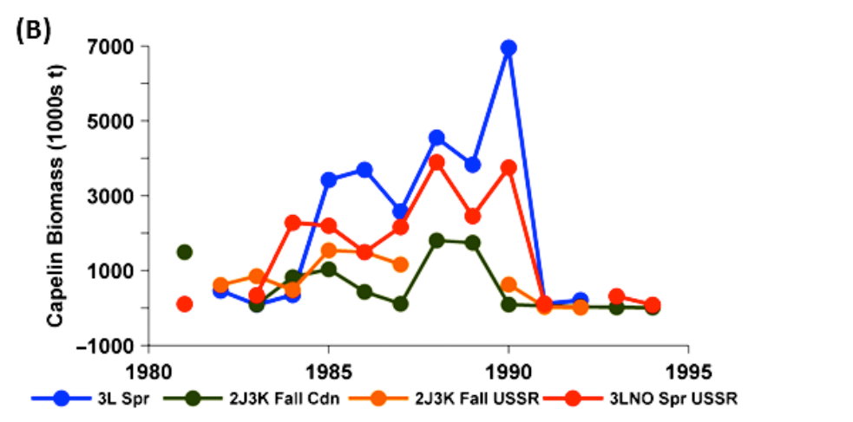

**Fig FM1 – Fig S1b taken from Frank et al.** Biomass estimates from capelin surveys in the NL region compared to the ongoing Div. 3L survey up to 1994.

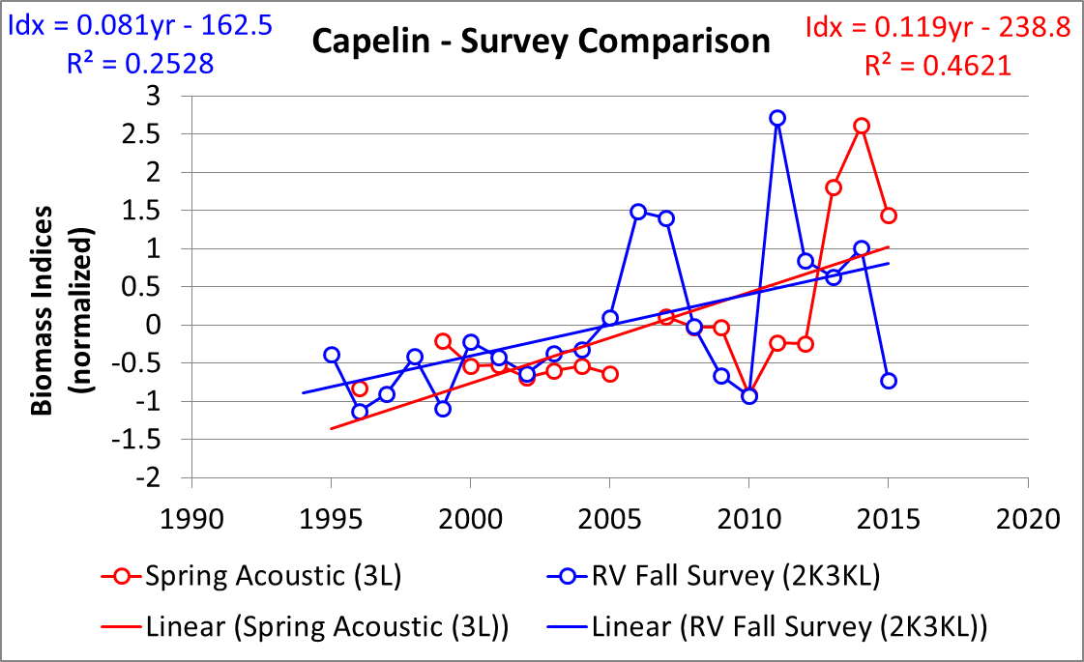

Fig FM2 – Temporal trends in spring acoustic and bottom trawl abundance estimates from 1995-2015.



Fig FM3 – Age composition by Nafo Division of capelin captured in fall 2J3K(L) acoustic surveys and in Campelen Fall 2J3KL bottom trawl surveys during period of different spring abundance index levels.

Figure FM4– Age composition of capelin found in the spring 3L acoustic survey from 1985-2015. Hatched bars indicate immature individuals. (2015 assessment excel)



**A**

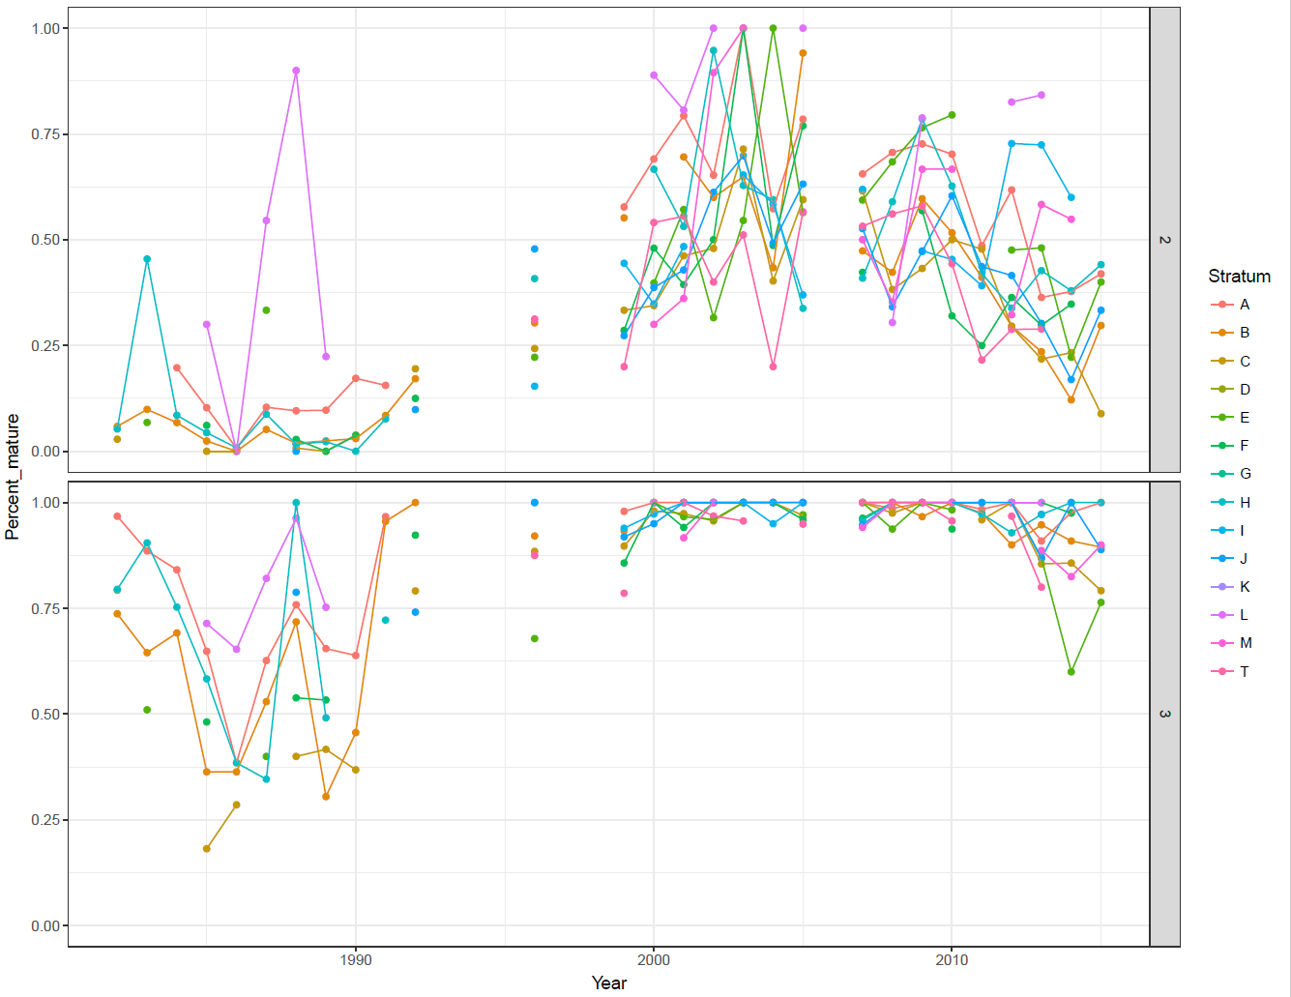

**B**

Figure FM5 - NAFO Division 3L with stratum boundaries used during spring acoustic capelin survey indicated (A); the proportion of maturing capelin by age (2- upper, 3 lower) and survey stratum as observed during surveys from 1982-2015 (**B**).



Figure FM-6 Inshore seasonal survey site Trinity Bay indicating the postion of acoustic transects (solid lines) and 100, 200 and 500 depth contours (dashed lines).

Figure FM-7 –Maturity stage composition (Upper) and age composition (lower) of capelin sampled in Trinity Bay during sesasonal surveys 2002 -2007.

Fig FM-8 Seasonal biomass trends in Trinity Bay May 2003-Sept 2005. Blue bars amounts in the main bay and red bars are those in the arms and bottom of the bay. May surveys of the main bay were conducted as part of the SOAS. There were no estimates of capelin in the Arms May surveys.

Figure FM-9 Offshore acoustic index (red diamonds) and Trinity Bay May acoustic index (blue diamonds) from May surveys conducted 1998-2017. Dashed grey line indicate 95% confidence limits indices.







Figure Age Composition Age composition of fish caught in the spring acoustic survey (top panel), and by the inshore commercial capelin fishery in Division 3K (middle panel) and Division 3L (bottom panel).



Figure Mortality Index of total mortality for capelin in Division 3L estimated from the spring acoustic surveys. Time series of the index are provided for capelin between ages 2 and 3, 3 and 4, 4 and 5, and 5 and 6. The time series for capelin between ages 1 and 2 is not shown as age-1 capelin are not fully recruited to the trawl gear. Note that values for 2010 over estimate the index of total mortality while values for 2011 under estimate the index as the 2010 survey had poor coverage of the capelin population and the abundances for the same cohorts a year later were somewhat higher.



Figure X. Map of center of gravity estimates of the distribution of capelin estimated using a geostiatical model fit to capelin bycatch from the fall 2J3KL multispecies survey from 1995 to 2016. Warmer (red) colours of the year labels indicate years with higher abundance estimates, and cooler colours indicate lower abundance indices (blue). The deep red shaded area indicates the portion of the inshore not surveyed by the multispecies survey and the lighter red area indicate inshore strata that are sporadically covered by the survey.